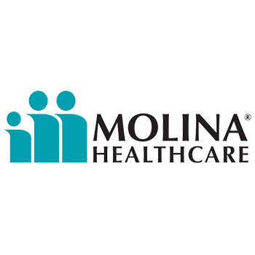

**Crossroads Treatment Center**

**Grand Opening**

**Health & Wellness Fair**



**Location**:

**Crossroads Treatment Center:**

**4928 109th St SW Lakewood, WA 98499**

**Suite A**

***\*Behind O’Reilly Auto Parts off Bridgeport Way SW\****

**Date**: **March 16th, 2019**

**Time:** **10:00am -2:00pm**

**JOIN US TO:**

**-Enroll in low-cost or no-cost health ins.**

**-Connect with primary care and behavioral healthproviders**

**-Learn about treatment benefits**

**-Participate in Children’s Activities**

**-Eat Light Snacks**

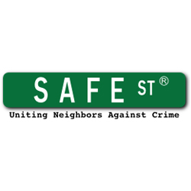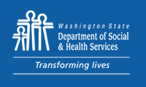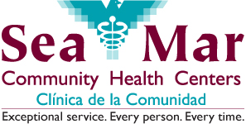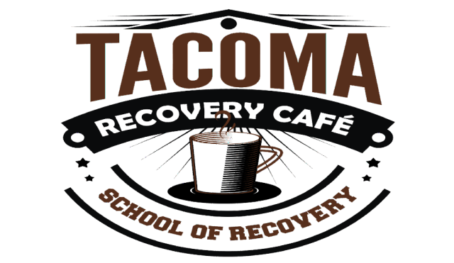Goodwill Industries International, Inc.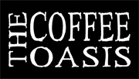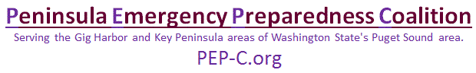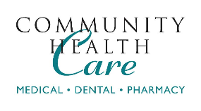

**Comprehensive**

**Life Resources**