Tacoma Pierce County Coalition to End Homelessness Weekly Meeting Agenda February 7th 2020
9:00 | Introductions and Announcements  Purpose: know who is in the room and prepare for the meeting  Leader: James Pogue, Comprehensive Life Resources - jpogue@cmhshare.org
9:15 | Fair Housing Discrimination Complaint Process  Purpose: Understand how to file a Fair Housing complaint, who can file, and how the process will work  Leader: Wesley Taylor, City of Tacoma - wtaylor@ci.tacoma.wa.us
9:55 | College Housing Assistance Program (CHAP)  Purpose: Learn about the additional capacity in the expanded program  Leader: Jess Thompson, Project Manager, Tacoma Housing Authority - jthompson@tacomahousing.org
10:00 | Increase emergency shelter capacity and Address homelessness in Tacoma  Purpose: Learn how to assist Metropolitan Development Council, Associated Ministries, and the Tacoma Ministerial Alliance as they engage the community to increase shelter capacity.  Leader: Rob Huff, Metropolitan Development Council - rhuff@mdc-hope.org
10:05 | City of Tacoma Updates  Purpose: Understand current work involving the City, and a time for questions and answers  Leader: Tiegan Tidball, City of Tacoma - TTidball@cityoftacoma.org
10:10 | Advocacy Update  Purpose: understand how to advocate for policy improvements  Leader: Maureen Howard, Senior Policy Analyst - maureenhowardconsulting@gmail.com
10:20 | Palmer Pathways Program  Purpose: Understand City of Tacoma resources for addressing employment discrimination  Leader: Julie Sandstede, Business Engagement Coordinator, Palmer Scholars - jsandstede@palmerscholars.org
10:55 | Networking  Purpose: “It is absurd to divide people into good and bad. People are either charming or tedious.” – Oscar Wilde  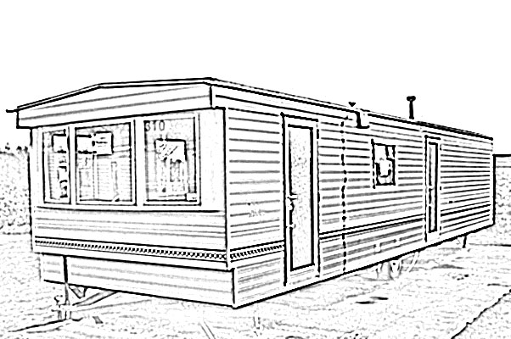  Leader: James Pogue, Comprehensive Life Resources - jpogue@cmhshare.org
Next Meeting: Friday, February 14th - 9:00am – The Salvation Army Church
Contact Gerrit Nyland (gerritn@ccsww.org or 253-304-5105) to add an item to the agenda.
Coming meetings, meeting minutes, listserv self-signup and more at http://www.pchomeless.org/
Resources Guide: https://www.piercecountyresources.com/
T-shirts are free – grab one

Committee 2019-20 Work Plans
Racial Equity |  | Leadership Team:  Heidi Nagel – Comprehensive Life Resources –  hnagel@cmhshare.onmicrosoft.com  Benjamin Feldbush, Comprehensive Life Resources -  bfeldbush@cmhshare.org
Charter: Better serve communities of color
Goals | - In Development

Workforce Development |  | Leadership Team:  Kelly Blucher, Goodwill - KellyB@goodwillwa.org  Sherri Jensen, Valeo Vocations sherri@valeovocation.org
Charter: Increase income through employment
Goals | - Get 10 organizations enlisted in the 253Works Job Club program  - Organize 3 Hire253 hiring fairs  - Increase Hiring success at Hire253 to 110% of all attendees

Advocacy |  | Leadership Team:  Cynthia Stewart – League of Women Voters - stewdahl@comcast.net  Carolyn Read – St. Leo’s - readcarolyn@comcast.net  Maureen Howard, Senior Policy Analyst –  maureenhowardconsulting@gmail.com
Charter: Advocate for better laws, policies and funding around housing and homelessness
Goals | - Connect to 4 other key advocacy groups around homeless issues  - Develop selected policy and funding action agenda for Pierce County, Tacoma and 2020 WA St. Legislature

Innovative Shelter Team |  | Leadership Team:  Theresa Power-Drutis, New Connections - tpdrutis@nctacoma.org
Charter: Increase temporary and permanent shelter stock for individuals with very low income
Goals | - Identify rural tiny house village site and agency to fundraise for and operate site  - Establish Tent City site and agency to fundraise for and operate site  - Advocate for other alternative, temporary shelter options: Safe Lot; Youth Shelter; Urban Rest-stop.

Community Connections |  | Leadership Team:  Richard Berghammer, FBC - ministrycounseling@comcast.net  Pamm Silver – Pamm.Silver@MolinaHealthCare.Com  Sheila Miraflor – Molina - Sheila.Miraflor@molinahealthcare.com
Charter: Increase housing retention and client stability with the newly housed
Goals | - Develop a Mentoring program with periodic care conferences are recommended.  - Maintain continuity of support, beginning with Stability Site (or wherever) to their home.

